# Intro to Programming (Python)

Assignment 06

## Overview

In this activity, you will learn to work with functions. Once again you will create your own scripts and document your knowledge. Your documents will be reviewed by your peers, so make your document and code look professional.

This assignment will include the following:

1. Watch the Module Videos.
2. Review the following web pages.
3. Watch the following videos.
4. Apply your knowledge.
5. Document your knowledge.
6. Submit your work to Canvas.
7. Post your document on GitHub.
8. Perform a Peer Review.

## Step 1: Watch the Module Videos

Please watch the following Module videos:

**Module 06 Playlist:**

* <https://www.youtube.com/playlist?list=PLfycUyp06LG-7xrsqU6kCTOXr2TLDPgD2> (Opens to external site)

## Step 2: Review the following web pages

Please review the following web pages. These are shorter than the book and provide online resources you can use later.

* <http://www.tutorialspoint.com/python/python_functions.htm>(Opens to external site)
* <http://www.learnpython.org/en/Functions>(Opens to external site)

(Remember these additional links are to give you a different opinion / viewpoint of the material we are covering. You only need to review the web pages to see what is out there as a resource. You do not need to read them thoroughly. The idea is to expose you to many different ways of looking at these topics and provide you will link to sites you can use in the future.)

## Step 3: Watch the support videos

Please watch this video. It will explain things a bit differently, which helps with learning!

* Creating Functions: <https://youtu.be/qO4ZN5uZSVg>(Opens to external site)

## Step 4: Apply your knowledge

Now that you have reviewed the websites and videos, try to do the following task. This project is very **like the last one**, **but** this time you will **place the code** you created for working with your ToDo.txt file **into Functions and a Class**.

***NOTE:*** *Just in case you had problems with the last assignment, I have provided my answer script in the Module’s zip file! You can use either my script to get started or make your script from scratch.*

For those that want just a little help, here is the pseudo code from my answer file.

*#-- Input/Output --#  
# User can see a Menu (Step 2)  
# User can see data (Step 3)  
# User can insert or delete data(Step 4 and 5)  
# User can save to file (Step 6)  
  
#-- Processing --#  
# Step 1  
# When the program starts, load the any data you have  
# in a text file called ToDo.txt into a python Dictionary.**# Step 2  
# Display a menu of choices to the user  
  
# Step 3  
# Display all todo items to user  
  
# Step 4  
# Add a new item to the list/Table  
  
# Step 5  
# Remove a new item to the list/Table  
  
# Step 6  
# Save tasks to the ToDo.txt file**# Step 7  
# Exit program*

## Step 5: Document your knowledge

**Create** a simple document to outline the steps you took in performing this assignment. Make sure the document is in a Microsoft Word document (.doc or .docx).

**NOTE**: *Make sure you put it in proper, college level, formatting!*

## Step 6: Submit your work

Now, **place** both your .doc or docx file and your python .py file into a folder called Assignment06 and zip the entire folder. Afterwards, **upload** the new zip file to the class assignment page.

## Step 7: Post your document

You need to **post** your zip file on a public GitHub so that others may review it.

1) Login to <https://github.com> (Make a new account if needed!)

2) Use the repository you made in Module 05, called ***IntroToProg-Python***

3) Upload your file to the repository

4) Copy the URL to your document

5) Submit the URL in Canvas

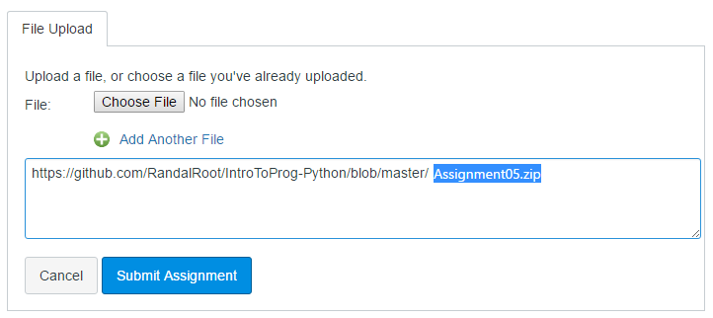

6) Post your link on the Canvas dicussion board so that others can see what you have created.

## Step 8: Perform a Peer Review

You will be randonly assigned a review parter by Canvas after the assignment due date. Please **download and read** the assignment turned in by this student and **comments** on the discussion forum.

You do not need to go into a great details about someones work, but you do need to include:

* One thing that you liked about their paper
* One thing that could make their paper better

***You are done!***